This is my simplified guide of "Getting started with Assembly" by Ahmed Shafeek

First, we want to download MS Visual Studio IDE using the link below.

For this semester we want the 2019 version since it is what the professor will be using in guides.

<https://visualstudio.microsoft.com/vs/older-downloads/>

Using this link above, you want to go to the 2019 dropdown and click download on the right. The download button should bring you to a portal where you need to fill in some information. After it has been filled out it should bring you to a homepage like this

Now click on downloads tab at the top left of the screen. Then you want to select Visual Studio 2019

You want to find the "Visual Studio Community 2019".(it should be 4th one down)

Click download, run the exe file, and continue to press what it tells you.

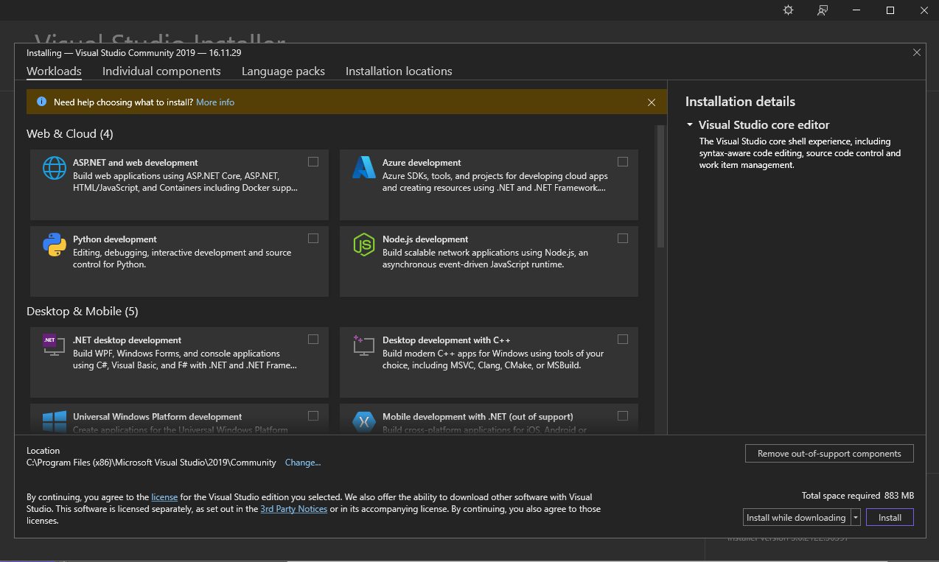

Afterwards you should end up with a screen like this ^

Under the Desktop & Mobile Tab you want to select the first 3

Sign in to your uwinsor account and select your UI mode and keep development settings on general.

Afterwards you should have a screen like this.

Now you want to create a new project. Here you want to find empty project with the tag c++

Next you will get a screen like this. Here you want to edit the file path to create a new folder

By clicking the highlighted box above you want to go into the file explorer, go back to source folder, and create a new folder for Comp 2660. After you are done it should be like this.

Now click create and you will be greeted with a screen like this.

Now you want to right click the project to go to build dependency and select build customizations.

So after you click that you want to select masm(.target, .props) and then click “ok”

We are almost done. We want to install Assembly Library Files

<https://github.com/NahiyanSayeed/FallTermProjects/blob/main/COMP2660/Library%20Files%20(1).zip>

After the installation you want to extract the zip file in your default assembly folder

We did this so we can have quick access to Library files since we will need it for every project.

(I put the txt file into “Library Files”)

Now we copy paste the contents of “Library files” to this folder

After this, we just need the txt file open.

**Select C++ file, and in the name tab change the extension from “.cpp” to “.asm”**

A terminal will open and we just need to copy paste from “assembly program template.txt”

Congratulations we are now set up and ready to go.

If you want the colour code like in VS Code follow along for a few extra steps.

Go to this website and download the addon

<https://marketplace.visualstudio.com/items?itemName=Henk-JanLebbink.AsmDude>

Run the VSIX installer

Click Install and let it finish, then restart visual studio and the end result should look like this

Thank you for reading the guide, if you have any questions contact me on discord (#Spondy_2511)

